# CVS Retail Store and Target Retail Pharmacy Closures

Reminders

Questions and Answers

Maintenance Choice Member Notification Letter

Member Notification Letter

Related Documents

**Description:** Information about the annual closing of retail CVS Stores and how to redirect our members to an open location near them.

|  |
| --- |
| Reminders |

CVS Health is taking steps to make health care more affordable, accessible, and convenient for consumers. This includes a new CVS Pharmacy retail footprint strategy that is aligned to the evolving needs of consumers.

CVS Health evaluates changes in population, consumer buying patterns and future health needs to ensure the right kinds of stores in the right locations for consumers.

As part of this initiative, CVS Health began closing:

* [Retail stores (50545)](https://thesource.cvshealth.com/nuxeo/thesource/#!/view?docid=a16f0bdd-ded1-494b-8691-3e7e261267c9) in certain locations in the spring of 2022 with the goal of closing 300 stores a year for the next three (3) years.
* Target pharmacies in certain locations beginning February 2024. No additional stores are planned for closure after April 2024.

New retail store formats were created to improve member/customer engagement. Three distinct models serves as community health destinations:

* Sites dedicated to offering primary care services.
* Enhanced version of HealthHUB locations with products and services designed for everyday health and wellness needs.
* Traditional CVS Pharmacy stores that provide prescription services and health, wellness, personal care, and other convenient retail offerings.

Our CVS Pharmacy team designed a patient outreach plan to accomplish three (3) objectives:

* Clearly communicate the [closing date of affected store list (050545)](https://thesource.cvshealth.com/nuxeo/thesource/#!/view?docid=a16f0bdd-ded1-494b-8691-3e7e261267c9) and next steps for a patient to refill a prescription.
* Provide care and support to patients affected by a store closure to ease disruption to their routine.
* Provide extra support for patients affected by a store closure who have complex care plans.

Top of the Document

|  |
| --- |
| Questions and Answers |

Refer to as needed:

|  |  |
| --- | --- |
| **Question/Statement** | **Answer/Resolution** |
| How soon will members/customers be notified of a store that is closing? | Approximately three weeks prior to the store closing, the store colleagues inform and facilitate the transfer of prescriptions to the receiving store, or another CVS location, based on patient preference. |
| How can I assist members in locating a store near their home? | The member can perform this search using their member portal, Caremark.com or similar.  Refer to:  [Caremark.com Pharmacy Locator (076403)](https://thesource.cvshealth.com/nuxeo/thesource/#!/view?docid=5cd07716-e1d2-4dcc-beb2-a8701aceeaf8)  [Aetna Member Website - Find a Pharmacy (003997)](https://thesource.cvshealth.com/nuxeo/thesource/#!/view?docid=5625687e-90e7-40b4-b788-bbce50c9635b)  **or**  You can search for them refer to [Retail Pharmacy Details and Locator (023842)](https://thesource.cvshealth.com/nuxeo/thesource/#!/view?docid=6c209183-6f8f-4e38-9647-7952ab652433) or [Compass – Retail Pharmacy Search and Details (057995)](https://thesource.cvshealth.com/nuxeo/thesource/#!/view?docid=ede79ef0-e196-481c-9f1b-c4ea562d9025) |
| What if the member picks up their Specialty prescription at the store that is closing? | We will communicate with CVS Caremark patients who elect to have their specialty prescriptions shipped to a CVS Pharmacy for pickup through our Specialty Connect offering and who currently have their medications shipped to a store that will be closing.   * Shipments to the closing store stop two weeks prior to the closure date. * When a refill is placed, the CVS Pharmacy team confirms delivery location with the patient. If the store is closing, they ask the patient to select another delivery location. * If a patient places an order online, the pharmacy team reaches out to the patient to confirm an alternate delivery location. |
| What is the text message that will be sent to me about the store closing? | **CVS Retail Pharmacy:**  Your CVS Pharmacy at <store address> will close on <date>. You can continue filling your prescriptions at <store address> or any other CVS location.  **Target Retail Pharmacy:**  We’ve made the difficult decision to close the CVS Pharmacy in the Target store at [ADDRESS] in [CITY] on [MONTH] [DAY]. All prescriptions will be transferred to the nearby CVS Pharmacy at [ADDRESS] to ensure patients have uninterrupted access to pharmacy care. Patients can always choose to fill their prescriptions at any CVS Pharmacy, or the pharmacy of their choice, if another is more convenient. Employees are being offered comparable roles within the company.    Maintaining access to pharmacy services in the communities we serve is an important factor we consider when making store closure decisions. Other factors include local market dynamics, population shifts, a community’s store density, and ensuring there are other geographic access points to meet the needs of the community.    We have [XX] CVS Pharmacy locations in [CITY] and will continue to provide the community with outstanding service at these locations. We also offer prescription home delivery service to eligible patients through CVS.com and the CVS Pharmacy app to provide additional convenient access to medications. |
| Which members/customers will receive an outreach notifying them of the store closing? | Those with an active prescription. Members/customers with expired prescriptions will not be notified. |

Top of the Document

|  |
| --- |
| Maintenance Choice Member Notification Letter |

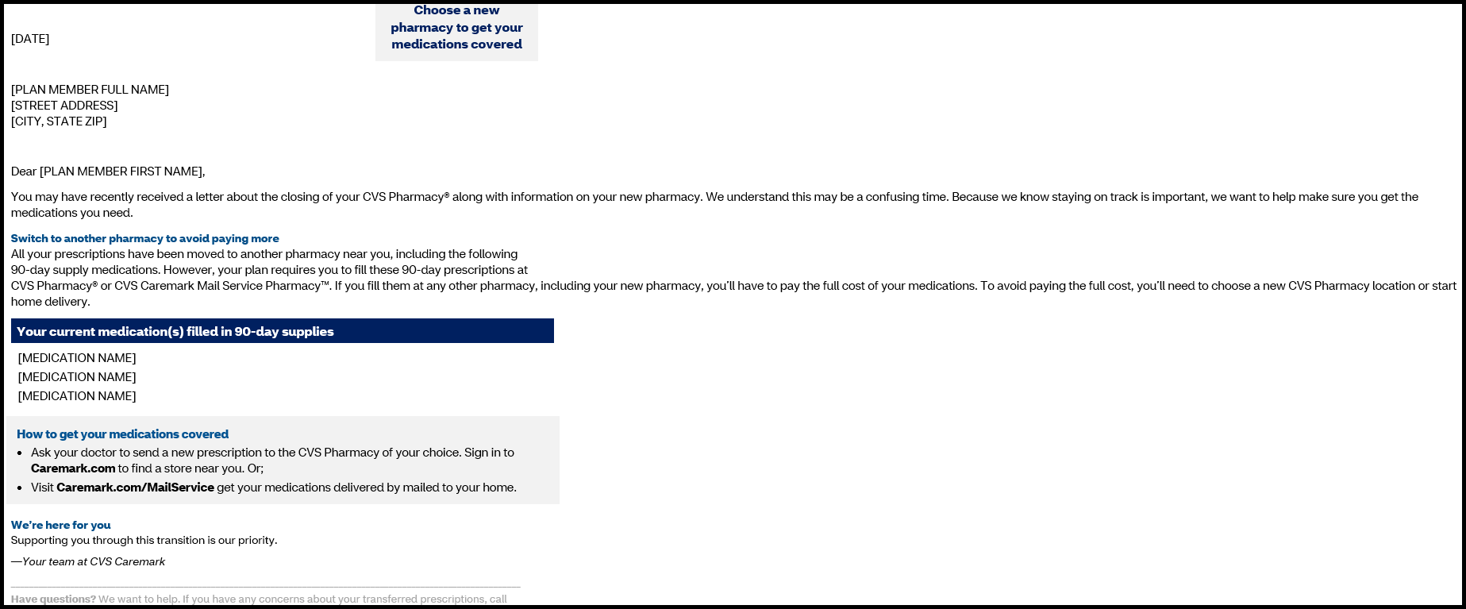

Top of the Document

|  |
| --- |
| Member Notification Letter |

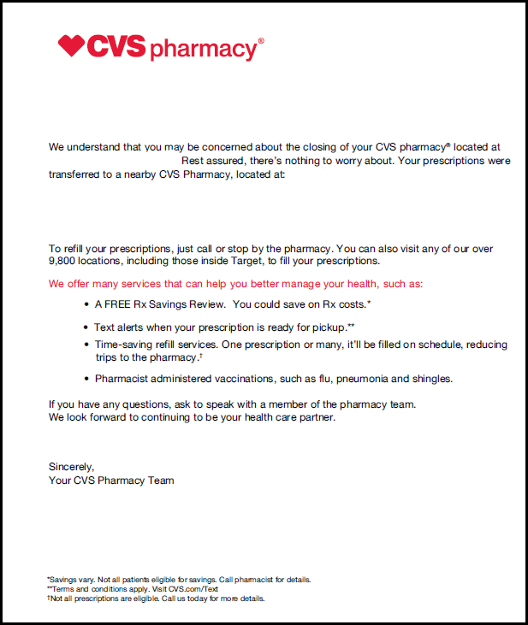

Top of the Document

|  |
| --- |
| Related Documents |

[CVS Retail Store Closure List (050545)](https://thesource.cvshealth.com/nuxeo/thesource/" \l "!/view?docid=a16f0bdd-ded1-494b-8691-3e7e261267c9)

[Customer Care Abbreviations, Definitions, and Terms Index (017428)](https://thesource.cvshealth.com/nuxeo/thesource/#!/view?docid=c1f1028b-e42c-4b4f-a4cf-cc0b42c91606)

Top of the Document

Not to Be Reproduced or Disclosed to Others without Prior Written Approval

**ELECTRONIC DATA = OFFICIAL VERSION / PAPER COPY = INFORMATIONAL ONLY**